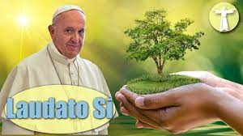
Job Application
Application to be on our Eco School Committee
“Looking after Our COMMON WORLD”
Important: *Please check School Website for Job Description.
We are trying to cut down on the use of Paper. #saveourtrees
__________________________________________________________________________________________________________________________________________________________________________________________________________________________________________________________________________________________________
Return to Mrs England on Monday

Job Description
- To show a very keen interest in looking after our planet.
- To care for the Environment.
- To love the Outdoors and to care for Our World Around Us.
- To share ideas on how to protect our World for the future.
- To know a little about Biodiversity.
- To have some creative ideas and thinking skills. (We want to continue to make our school “Greener”. For example: Reduce, Reuse, Recycle, Saving energy and water, reducing Waste and learning in the Outdoors, especially in Our beautiful school garden).
- To be a good listener and to work well in a Team.
- To be able to discuss and share ideas in a mature way.
- To be willing to gain experience in speaking to classes or the whole school community to promote Eco-Schools and enrich your own Personal Growth and Value.
#walkinginfaithandlove #keepnorthernirelandbeautiful
#derrydiocesancentre #saveourplanet
#popefrancislaudatosi
#loveourworld
#eco-warriors
#stcolumbasps
#welovetheoutdoors

